tinyurl.com/LamarWritingLab

IB Mathematics: Analysis and Approaches HL2 IA

Mathematical Exploration

Overview of Written Mathematical Exploration
Mathematics Analysis & Approaches HL:  Mathematical Exploration  Title of your exploration  Page Count  [1] | Table of contents  [2] | Introduction  Personal interest and intentions/purpose for mathematically exploring topic  Aim  Research Question and overview of sections in sequence  [3] | Sections A-n  Explain Method and Data  [mathematical representation(s): graphs, tables, diagrams, calculations]  Analyze Results in Writing  (describe graphs, tables, diagrams, calculations)  Engage Results and Reflect on Process:  Plug back into Real-World Context,  Critical Reflection on Validity/ Limitations  …Transition to next section  [4]
Conclusion and Discussion  Summarize results as an answer to the aim of your exploration  Reflect on validity, limitations, omissions/ assumptions with respect to real-world context  Suggest further or alternative research, Identify next steps for applying your findings, Comment on what you learned or discovered.  [5] | Bibliography  Include full MLA citations for any and all:  Sources of data,  Sources for images,  Sources of background info,  Previous studies you reference,  Math reference sources used  Citation generator and guide linked here!  [6] | Appendices  Tables of raw data  Survey(s)  Supporting documentation  [7] | Candidate declaration  I confirm that this work is my own work and is the final version. I have acknowledged each use of the words or ideas of another person, whether written, oral or visual.  Candidate’s signature: .................................................  Date: .............................  [8]

Figure 1: Textbook diagram of Mathematical Modeling Process
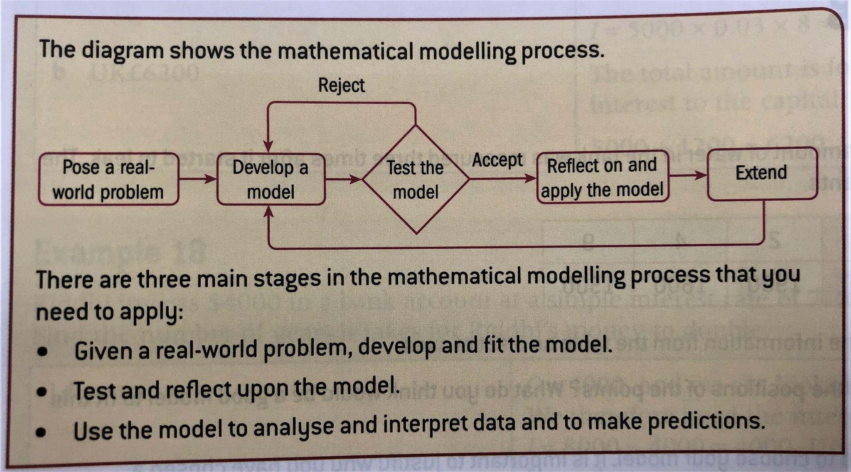
(Wathall, et al., 248)

Wathall, Jennifer Chang, et al., Mathematics: Applications and Interpretations, International Baccalaureate Standard Level Course Companion, Oxford UP, 2019.

Introduction (.5 - 1 page)

Personal interest and intentions for mathematically exploring topic

Personal interest (Hook/Wind-up): Opening sentences identify the topic and set the scene where your interest in the topic sparks.

Intentions for mathematical exploration (Pitch): Connect this experience of initial interest with your present intentions for exploring the topic using mathematics→something you want to do, make, or know outside of math class

- Curious about how to optimize something, or the “best” way to achieve something
- Applying math to a personal project or goal
- Applying math to understanding or building on another IB course
- Applying math to a situation in which you could offer strategies or advise on a course of action
- Applying math to real world issues in industry, policy, education, marketing, etc…

Example Phrasing:
My interest stems from a personal experience I had…
…This led me to question, [statement of research question]

Driven by my passion for…/ I wanted to…
…I decided to explore it from a mathematical perspective and find…

→ Here you are
- Posing a real-world problem of personal interest, which establishes the context and motivation for the exploration
- leading into your stated research question that mathematically represents the situation,
- and introducing your mathematical exploration as your plan to answer that question

Aim (.5 - 1 page)
This is where you demonstrate your understanding of the course mathematics you will apply and how they build toward an answer or solution to your question.

My exploration seeks to / aims to / addresses / investigates…
The purpose / focus of my exploration, therefore, is to…
My objective is to…
I designed my mathematical exploration to test the hypothesis that…

More phrases for specifying the type of study:
an initial study of … an exploratory study of … a pilot study of … an overview of …
a survey of … a comparative study of … a comparative investigation of …
a comparison of … a statistical analysis of … an empirical study or investigation of …
a series of experiments to conduct an experiment on … a field study of …
a case study of …

Overview of Exploration (Methods/Process)
What you’re doing…
Outline the sequence of mathematical steps you take to construct an answer to your question. Use the mathematical and technical terms learned in class.

- Identify how the data will be collected, sampled, sourced and why (=give your reasoning why the collected data is appropriate)
- State the mathematical processes and tools you will use and why (=give your reasoning why the math and tech are appropriate).
- Link each step with transition words and phrases to clearly establish the development or advancement toward finding an overall answer or solution

Ways to say it…
To answer this question, I will use / need to find / develop___. I will then further develop my exploration by___.
First, I will use _____ to ______. I will then _____ in order to ____.
I will then use ____ to establish if ____.
Then, I will investigate ____ to see if ____.
Next I will ____ to determine _____.
Finally, ____ .

Phrasebook PDF: Stephen Howe, Kristina Henriksson - PhraseBook for Writing Papers and Research in English-CreateSpace Independent Publishing Platform (2007).pdf

Phrases for explaining your methods and reasoning
(Methodology: Methods + Reasoning)
*Select from these phrases when giving the overview of your methods in the “Aims” section and when introducing/explaining the math you use in each section.

These phrases also boost your “personal engagement” score, which evaluates how clearly you recognize and explain the purposes of the math processes used to help achieve the aim.
Method
by examining … … is or can be obtained by … with the help of … with the aid of …
by means of … by application of … A useful tool for … is … an indispensable tool in …
this device enables us to …
we have a number of techniques at our disposal
…, drawing on …
incorporating a number of … in the context of … in conjunction with … based primarily on …
a process involving … within the framework of …
a or the frame of reference
First we select … ; we then select …
Stage or step 1 involves …. In stage or step 2, we … Phase 1 …; phase 2 …; phase 3 …
We used …
… to study the effects of … on … … to examine the effects of … on …
… to model the effects of … on … … to estimate the effects of … on …
To determine whether …, we … To assess whether …, we …
To measure the effects of … on …, we … To assess whether … was affected by …, we …
To investigate whether …, we analyzed …
… was or were measured by … … was determined for each … by …
… was measured before and after … … was used to measure … … was equipped with …
… was transferred to … … was or is used in the analysis of … to determine …
… provides a useful estimate of or for … the simulation is used to … in the presence of …
in the absence of … after addition of … substitution of … for …
measurements were made or taken at … sites
For this we can use a number of strategies One option here would be to …
Adjustment of … allows us to … … is enhanced if we …
This method can be used to obtain … This technology enables us to …
The most usual method is …
… is commonly used in … to measure etc. … … by the … method
… according to the … method
The method etc. can also be adapted or extended to …
Using this method or technique, we are or were able to …
Data Sources and Collection
primary sources were: secondary sources included … an extensive database
to collect data on …
We obtained data on … from … Data on … were collected … … by …
… between … and … … during … … at regular intervals … … continuously
The data were or are compiled from a number of or several sources
Continuous measurements of … were made …
Sampling of … was carried out over a two-week etc. period in ___.
Conditions during the sampling period were …
a random sample of … … selected or chosen at random from …
… randomly selected from … … provides a representative sample of …
It is estimated that there are …
No data were available for or on …
Reasoning - engagement and reflection
to verify … to establish … to facilitate … to capture … to measure accurately …
the reason for this is … Because of this, … it should be stressed that …
we might expect that … it is convenient to … it is helpful to consider …
It is helpful here to … In practice, … the application of … to …
Particular attention will be paid to … to examine more closely
… will be or was investigated further by … … will be examined in greater detail
Based on …, we decided to … This has been shown to … In doing so, …
it will be useful to examine … … deserves special attention we opted to …
from this perspective This approach is based on … … is frequently used to …
The experiment was designed to … The advantage of this approach is that …
This approach has the advantage of or that … This approach has a number of advantages: firstly, …
… gives a better basis for … it combines … with or and …
This format allows us to see more clearly how … In this way, we are or were able to target …
This enables one to create …
In this way, we are able to eliminate several of the problems of previous approaches or methods
One difficulty in … is … A or one significant problem is …
Coordination of … and … is essential or particularly difficult a compromise
One strategy would be to … … avoids this difficulty by …
the practical problems involved in … an alternative way of approaching the problem
Another way of looking at the question of …

Criterion B: Mathematical Communication | Phrases to include in each section
Write all mathematical expressions using the Insert > Equation function in your Word or google doc  Define all variables with the value and units they represent. | To determine ______, the following formula is used:  $Y=x^{2}+v$  where Y is ____ in [units], x is _____ in [units], and v is ____ in [units].  We can calculate _______ with the function  $f(x)=x^{2}+v$  where x is _____ in [units], and v is ____ in [units].
Define variables, units, and how you collected the data points for EVERY table, graph, diagram, etc., near where it appears in the report. Identify software or technological tools you used to produce the representation. | Definitions, notation and terminology  the types of … in terms of …  with reference to …  this formula allows us to …  We defined … as …  By … we mean … By … is meant …  … is defined as … … can be defined as … … is or are often defined as …  … are defined in this study as follows:  … can be characterized as … … can be formulated as follows:  … denotes … … represents … is representative of …  …, which is or are represented here by or as … … can be written as …  Data Sources and Collection  primary sources were: secondary sources included … an extensive database  to collect data on …  We obtained data on … from … Data on … were collected … … by …  … between … and … … during … … at regular intervals … … continuously  The data were or are compiled from a number of or several sources  Continuous measurements of … were made …  Sampling of … was carried out over a two-week etc. period in ___.  Conditions during the sampling period were …  a random sample of … … selected or chosen at random from …  … randomly selected from … … provides a representative sample of …  It is estimated that there are …  No data were available for or on …  Presenting data  … can be expressed more simply as …  … is or was determined as follows: … is or was measured by …  … is or was calculated as follows: … is or was calculated by …  where … is the … represents denotes
Title every table, graph, diagram, etc., and clearly label… | For example:  Tables: Each column and/or row, with units  Graphs: Axes with units, label significant points with variables and define them in the text  Number each table, graph, diagram, etc., sequentially with Figure #. Wherever you refer to it in the text, include the figure number like this: (Fig. #).
For each mathematical representation of the data (table, graph, diagram, etc.), identify and interpret what it shows in writing. | This table / graph / diagram of the data suggests / hints / implies / shows…  We can see in the table / graph / diagram above that…  Presenting Data  The proportion of … ranged from … to … ranging from … to …  … ranked in order of … … is proportional to …  … was significantly higher in … than in … … was significantly lower in …  … peaked at … … was higher than expected  … was lower than expected the expected number of …  Figures, tables and graphs  table X shows … figure X illustrates … as seen in figure X  as shown in the table above or below  examples of … are shown in figure or table X The image shows that …  The figures, data etc. … … are given above … are presented below  … are shown in table X … are listed above or below  … are summarized in figure or table X … are illustrated in figure X  … are illustrated in the figure, graph or table above or below  … are shown in the graph above or below … are shown in brackets or parentheses … are given in the appendix Figure X shows …  … the size of … … the level of … … the extent of …  … the effect of … … the rate of … … the concentration of …  … the distribution of … All values are given as …  each column represents … The shaded area represents …  … based on the data given in table X  Values in brackets or parentheses are …  An alternative way of presenting … is to …
Use these phrases in the body sections to analyze the results of mathematical processes, calculations, and representations.  Also use “discussion” phrases to demonstrate critical reflection and personal engagement. | Analysis and discussion  to examine … to examine … more closely to observe … to observe … in detail  to evaluate … to assess … to assess the significance of … In determining …, …  to determine whether … whether or not … We observed … By analyzing …,  … was analyzed by or for … The analysis here is based on …  It is relatively easy to describe … one immediately obvious feature of … is …  A quick glance at … shows that …  … exhibit classic signs or symptoms of … From … it is apparent that …  … is immediately apparent … is most pronounced in … … shows evidence of …  Superficially at least, … Underlying … is the view etc. that …  Analysis of the data revealed … Closer examination of … reveals that …  Closer inspection revealed that … Viewed in this way, …  There is some indication that … Observations of … suggest that …  The presence of … can be tested by … An important test for … is whether or not …  … may be or is confirmed by … … tends to occur or be found in …  exposure to … results in … One way of examining or viewing …  Discussion  The importance of … is demonstrated by the fact that …  … assumes a special significance because or as …  One of the most obvious consequences of … is  the or an important observation that … A point that can be made is that …  This may be discussed in terms of … … is perhaps best viewed as …  If this is the case, then … This attests to … This agrees with …  … is or are, in effect, … … supports the notion that … … may be inferred from …  This would suggest that … There is some evidence to suggest that  The question arises whether … It is an open question whether …  This raises a further question: This raises the issue whether …  This raises a number of questions.

Criterion D: Reflection | More phrases for concluding reflection and discussion…
Critical Reflection - Limitations  Other perspectives | One may question whether …  a number of reservations/limitations  One cause for concern is …  It is not necessarily the case that …  it would be more accurate to say that …  a more promising approach would be …  a more plausible explanation would be that …  … must be examined more closely  … cannot be accepted as it stands  more needs to be said about …  However, given these reservations, …  Despite these reservations, …  Despite these limitations, …  Given these qualifications, …  Other possible explanations or causes are …  An alternative explanation would be …  One possible explanation for … is …  A more plausible explanation for … would be that …

